Homework 4

1.3.4 Maximum Height

Initial guess:

tf = 0.5

ctrl.tf = 0.4

ctrl.T = [1.5 1.5 1.5]

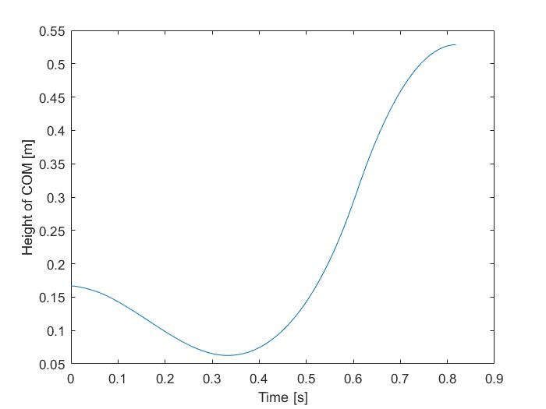

Final values:

tf = 0.818020223418949

ctrl.tf = 0.614915226320635

ctrl.T = [0.203099434247268 1.53862211745677 1.97092105380638]

objective value = -0.5286

1.3.5 Minimum Time to 0.4 m

Initial guess:

tf = 0.5

ctrl.tf = 0.4

ctrl.T = [1.5 1.5 1.5]

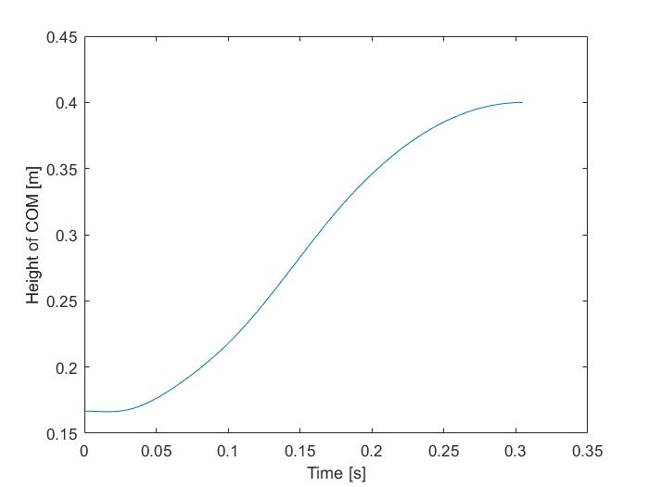

Final values:

tf = 0.304959609169827

ctrl.tf = 0.172827822046896

ctrl.T = [1.99998840345007 1.99998078052077 0.390695202451666]

objective value = 0.3050

1.3.5 Minimum Energy

Initial guess:

tf = 0.5

ctrl.tf = 0.4

ctrl.T = [1.5 1.5 1.5]

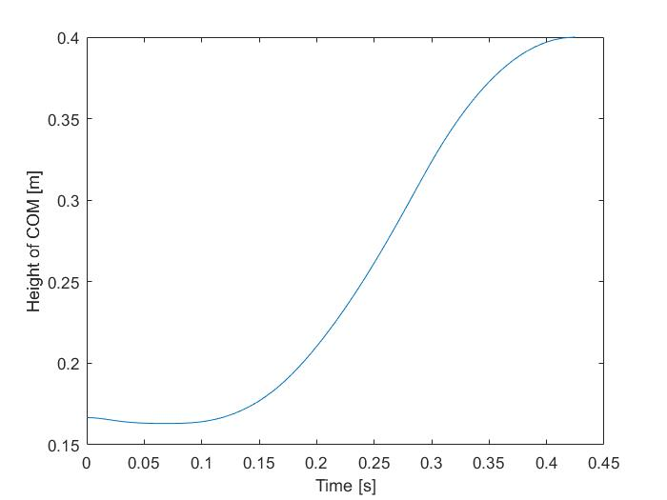

Final values:

tf = 0.424724793772440

ctrl.tf = 0.300935135789384

ctrl.T = [0.555972754971973 1.79426323042252 0.869050049443244]

objective value = 0.8897